**Standard Operating Procedure (S.O.P) for *Xenopus laevis* Oocyte cRNA Nanoinjection**

S.O.P. Prepared by Andrea Rodríguez, 2021

Modified by José E Lizardi Ortiz, Ph.D., 2022

This S.O.P. will direct you in the procedure of nanoinjecting cRNA into *Xenopus laevis* oocytes to express a protein of interest. This heterologous expression system could be used to perform different techniques, including electrophysiology (two-electrodes voltage clamp and single-channel patch clamp), imaging (including Ca2+ imaging), genomics, and proteomics. The nanoinjection system used in this S.O.P. is the Nanoject II (Drummond, cat. no. 3-000-204), but other companies also offer similar models.

Different factors could affect the protein expression, including incubation time, the cRNA mass to be injected, nanoinjection volume, changes in temperature, cRNA purity, and toxicity of the protein to be injected.

***Important:***

* ***The nanoinjection pipette tapper must be long, gradual (no inflection), uniform, and not thicker than 5 μm (3–5 µm), to avoid disruption of the oocyte plasma membrane.***
* ***The use of a horizontal capillary tube puller is highly recommended as it is better to produce nanoinjection pipettes with long and gradual tappers.***
* ***Large volumes will burst the oocytes when injected. Use less than 50 nL, preferably between 23 to 37 nL. To nanoinject these volumes, the cRNA must have an adequate concentration.***
* ***The area, equipment, and materials must be sanitized before placing them into the working area and during the procedure. Preferably use a cabinet with laminar air flow as a working area. The cabinet should allow the use of a dissection microscope.***
* ***The ND-96 buffer and any plate containing the buffer should be kept at the incubation temperature (~17 °C) when it is not directly used during the procedure.***
* ***The nanopipette cannot have air bubbles in the solution or the mineral oil phase. This is essential to obtain the correct volume by transferring the mechanical force from the “Plunger” to the tip of the nanoinjection pipette.***
* ***Check that the parameters for the capillary tube puller and the injector (in the control box) are correctly set.***
* ***It is always good practice not to nanoinject ten oocytes or fewer. This helps to determine the healthiness of the oocytes.***

*Materials*:

* 70% Alcohol or RNase Decontaminant (RNaseZap, *optional*)
* Waste Container with Bleach (2% sodium hypochlorite)
* Sharpie (any color)
* Kimwipes
* 2 µL Micropipette and Tips
* 50 mL Disposable Conical Tubes
* Disposable Plastic Bulbs (wide tip)
* ND-96 Media (*see Appendix A*)
* cRNA Sample (stored at –80°C; *see Appendix B)*
* Stage V and VI *Xenopus laevis* Oocytes
* Paraffin
* 60 mm Petri Dish with 1 mm Grids (Avantor 25382-392) or 60 mm Petri Dish with 0.8 mm polypropylene Mesh
* 100 mm Petri Dish with Non-hardening Modeling Clay (preferably Crayola)
* 48-well or 96-well Plate (non-treated for culture) or Petri Dishes (35−60 mm)
* Fine-tip Tweezers (Dumont #5, tip 0.06 mm)
* Glass Capillary Tubes (Drummond #3-000-203-G/X, 1.13 mm O.D., 0.5 mm I.D.)
* 1–3 mL Syringe with a Microfil Flexible Needle Filled with Mineral Oil (needle: 28G)
* Capillary Tube Puller (horizontal is preferred; *see Appendix C*)
* Dissection Microscope (2–5X magnification roulette)
* Nanoject II (control box + injector mounted in a micromanipulator)
* Cooling Incubator (17–18 °C)
* Vertical Flow Cabinet (o*ptional*)

*Procedure:*

*Oocyte Storage for Nanoinjection*:

1. Equilibrate the cooling incubator to 17 °C for at least 2 hours before receiving oocytes from an authorized source or surgical oocyte retrieval from X. laevis the oocytes.
2. To store the oocytes to be nanoinjected, add ~13 mL of ND-96 media (*Appendix A*) into a 60 mm petri dish and place it in the cooling incubator for at least 30 minutes before adding the oocytes. This will ensure that the media has reached thermal equilibration.
3. Incubate the oocytes for at least 1 hour before any procedure is performed.

*Setting Up the Working Space*:

1. This S.O.P. is designed for 50 oocytes. If the number of required oocytes is different, scale these instructions appropriately.
2. Turn on the vertical flow cabinet (if you are using one) and sanitize everything inside the cabinet/bench with 70% ethanol and RNase decontaminant (if it is available) before setting any materials on the bench. All materials that are brought into the cabinet/bench must be sanitized as well.
3. Prepare the waste container with 2% bleach for decontamination. ***Oocytes to be discarded must be decontaminated*** ***in this container for at least 30 minutes***.
4. Prepare a 48-well plate for storing nanoinjected oocytes by adding 500 µl/well of the ND-96 media and place it in the cooling incubator (17 °C) for at least 30 minutes to reach thermal equilibration. In addition, add 20 mL of ND-96 media into a 50 mL conical tube and place it in the same incubator
5. See *Appendix B* to determine the cRNA’s mass and volume to be injected per oocyte and the required concentration. Please verify that the position of the dip switches on the right side of the control box (Figure 1) indicates the volume to be used. The volume legend is at the bottom surface of the control box. ***The cRNA must have an adequate concentration to inject the desirable volume.*** ***Larger volumes increase the risk of bursting the oocyte.***

*Glass Nanoinjection Pipette Preparation*:

* 1. See *Appendix C* to select the appropriate parameters (or protocol) for producing nanoinjection pipettes using a horizontal capillary tube puller.
  2. Place the capillary glass tube symmetrically around the heating element of the puller and begin the pulling process. Once the glass breaks, transfer each nanoinjection pipette to the 100 mm petri dish containing a clay bump in the middle, carefully securing the pipette on the clay.
  3. Place the petri dish under the dissection microscope, adjust the magnification and focus, and break the pipette’s tip using fine-tip tweezers to the appropriate thickness (3-5 µm). Use a reference nanoinjection pipette if necessary.
  4. Point the frontal part of the Nanoject II injector toward you and be sure you have enough space around the injector to insert the nanoinjection pipette.
  5. Completely lower the plunger from the injector using the “Empty” button on the control box, and then retract the piston for 2 seconds using the “Fill” button. ***Do not touch the piston at any moment***.
  6. Loose the “Collect” of the injector slightly (Figure 2) and insert the empty nanoinjection pipette carefully to the top of the injector, ***avoiding to bend the piston***. Screw the “Collect” loosely and mark the pipette with a sharpie where the plunger tip ends.
  7. Loose the “Collect” and remove the nanoinjection pipette carefully, ***avoiding to bend the piston***. Backfill the pipette with mineral oil to ~1 cm up from the mark using the syringe with a microfil needle. ***Make sure there are no air bubbles during the whole procedure***. Flick the pipette a couple of times if bubbles are present*.* Reassemble the pipette in the piston, ***avoiding to bend the piston***, and screw the “Collet” tightly.
  8. Place the injector under the dissection microscope, bring the tip of the nanoinjection pipette to the center of the field of view and move up the tip end as far as possible from the stage plate of the microscope.

*Filling cRNA into the Nanopipette*:

1. Get a 35 mm petri dish, remove the cap, and place a piece of newly cut parafilm over the top by stretching the film. Center the dish under the microscope.
2. Thaw the frozen cRNA. Remember to vortex and centrifuge the cRNA tube. Transfer 2 μL of the cRNA on top of the parafilm surface. Center the droplet by carefully moving the petri dish with your hand.
3. Ensure the control box is set to the desired injection volume before starting.
4. Use course controls to move down the nanoinjector pipette tip and carefully insert the tip into the droplet without touching the parafilm to avoid damaging the tip. Once inserted, use the “Fill” button on the control box to fill the pipette. Work with time intervals in which you press “Fill” for three seconds and wait ten seconds for the suction to stabilize, repeating until it is completely absorbed. ***Make sure not to suck any air into the pipette during the procedure.***
5. Move up the tip as far as possible from the stage plate of the microscope.

*Oocyte Nanoinjection*:

1. Get a 60 mm petri dish with a grid/mesh and fill it with ~13 mL of the pre-chilled ND–96 media (*Setting Up the Working Space*, Step d). Place the dish under the microscope.
2. Transfer 20–25 oocytes from the cooling incubator into the petri dish and be sure they are held in place at individual grids. The oocyte animal pole (dark side) should be facing up to visualize when the nanoinjection pipette tip disrupts the membrane.
3. Position the oocyte to be injected at the center of the field of view by carefully moving the petri dish with your hand. Use course controls to move down the nanoinjector pipette and carefully bring the tip close to the oocyte top without touching it.
4. To inject the oocyte, place the nanoinjection pipette tip midway between the oocyte pole and equator and move the nanoinjector diagonally to carefully penetrate the oocyte by using the fine control of the manipulator. The oocyte will wring due to the surface tension of the membrane but will be released once the tip goes in.
5. Once the tip is inserted, push “Inject” on the control box and wait 10 seconds before withdrawing the nanoinjection pipette tip from the oocyte.
6. Carefully position the next oocyte in the center of the field of view egg and repeat *Steps d–f* until all oocytes are injected.
7. Once all oocytes are injected, carefully move the nanoinjection pipette diagonally as far as possible from the petri dish and transfer each oocyte to an independent well in the 48-wells plate (*Setting Up the Working Space*, Step d). Store the plate in the cooling incubator (17 oC). ***Be careful not to move the micromanipulator + injector setup if more nanoinjection are required***. ***In case the setup was moved, you need to center the pipette tip again***.
8. Transfer the rest of the oocytes to be injected from the cooling incubator into the petri dish and be sure they are held in place at individual grids. Repeat *Steps d–g*. ***Remember that it is always good practice not to nanoinject 10 oocytes or fewer. This will help you determine if the oocytes are weak/sick during the experimental day***.
9. Incubate the oocytes for the appropriate time to allow maximal expression. See *Appendix B* for incubation times for each protein.
10. Move up the nanoinjection pipette as far as possible from the microscope's stage plate and point the injector's frontal part toward you. Carefully remove the pipette from the injector, ***avoiding to bend the piston***, and discard it in the container for sharp objects. Hold the “Fill” button on the control box until the tip is completely retracted.
11. Carefully invert any remaining oocyte into the waste container with bleach and let the bleach solution rest for at least 30 minutes. Dispose the solution using the proper waste container and discard the materials in a biological waste (trash can with red bag).
12. The working area and any material should be sanitized using 70% ethanol at the end.
13. Be sure all equipment are shut down: lights, capillary tube puller, and vertical flow cabinet (optional). Return any material and equipment to their proper place. The pipettes must be returned to their maximal volume.

**Figure 1**

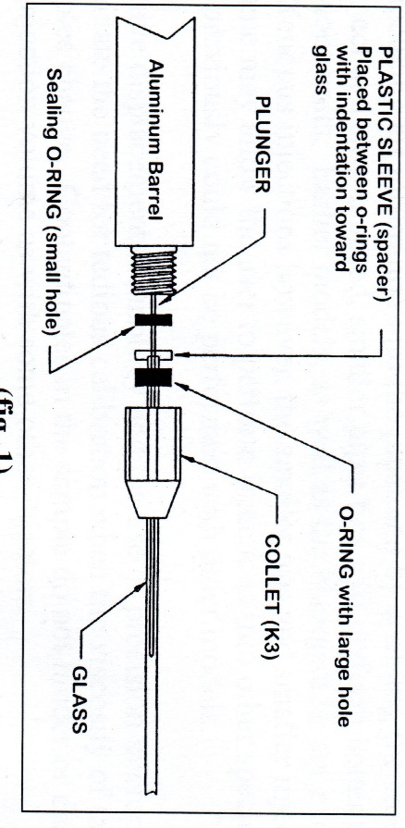**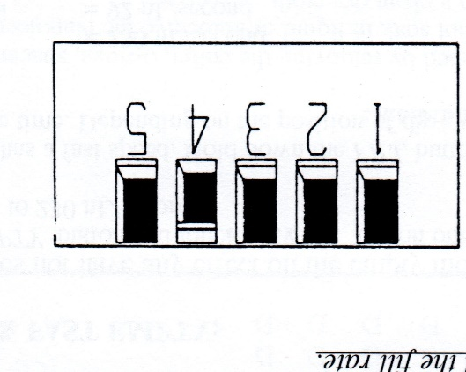Figure 2**



Appendix A

Appendix B

|  |  |  |  |
| --- | --- | --- | --- |
| **cRNA** | **Mass**  **(ng)** | **Volume**  **(nL)** | **Concentration**  **(ng/µL)** |
| α7 nAChR Columbia | 20 | 32.2 | 261.12 |
|  |  |  |  |
|  |  |  |  |

Appendix C

|  |  |  |  |  |  |  |
| --- | --- | --- | --- | --- | --- | --- |
| **Pull** | 83 |  |  |  |  |  |
| **Delay** | 200 |  |  |  |  |  |
| **Velocity** | 35 |  |  |  |  |  |
| **Filament** | 4 |  |  | **No. 2 Heater** | 68% |  |
| **Heat** | 380 |  |  | **No. 1 Heater** | – |  |
| **Protocol** | 42 |  |  | **Protocol** | Step 1 |  |
| **Type** | Horizontal |  |  | **Type** | Vertical |  |
| **Model** | P-2000 |  |  | **Model** | PC-10 |  |
| **Company** | Sutter Instruments |  |  | **Company** | Narishige |  |